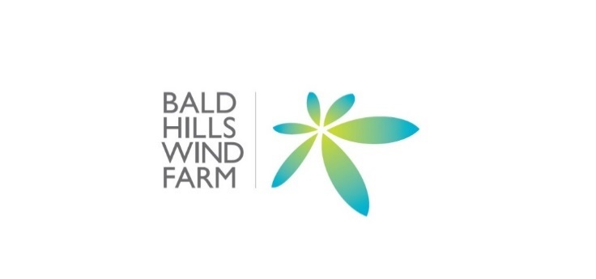
Media Release
10 November 2025

Bald Hills Wind Farm Community Fund Invites Applications for its 2026 District and Small Grants
The Bald Hills Wind Farm Community Fund (BHWFCF) is inviting organisation’s with community projects benefiting the Tarwin Lower, Venus Bay and Walkerville districts to submit applications for its 2026 District and Small Grants.
The District grant, is a single grant valued at up to $15,000, provides an exciting opportunity for a local organisation to develop a significant project to benefit the district community.
The Small Grants, which will be awarded up to the amount of $2,000 or $5,000 per project, are designed to enable organisation’s to provide a benefit or service to the local community.
Previous grants have funded such projects as:
- Infrastructure upgrades at The Tarwin Recreational Reserve, Mechanics Hall, Men’s Shed, and Venus Bay Community Centre.
- Safety equipment for the Tarwin Lower & District Rural Fire Brigade.
- Medical equipment for the Venus Bay & District Community Emergency Centre and Venus Bay & District Community Emergency Response Team Inc (CERT). Infrastructure improvements for the Tarwin Lower Primary School, Tarwin Lower Football & Netball Club and Tarwin Lower Tennis Club.
- Arts projects such as the Venus Bay Water Tank Mural project and the Thirsty Works Gallery; and assistance to the Tarwin Wildlife Shelter, Watch for Wildlife and Tarwin Landcare Group.

Grant applications will be available from 10 November 2025 until the closing date of 5:00pm 10 February 2026.

Information on Grant criteria and Application forms are available at http://baldhillswindfarm.com.au/community-fund/.

