VENUS BAY, TARWIN LOWER DISTRICT MEN’S SHED INC.
PRESENTS THE INAUGURAL
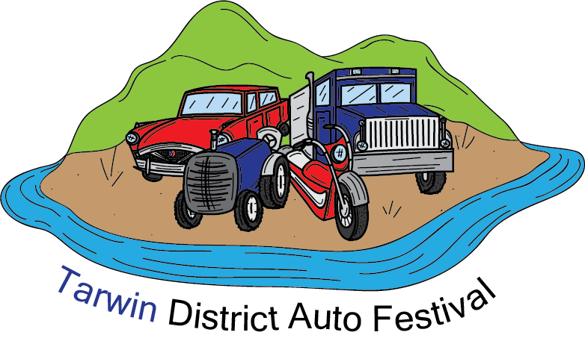
SUNDAY 3rd NOVEMBER, 2019, 9.30am – 3.30pm.

TARWIN LOWER RECREATIONAL RESERVE
WALKERVILLE RD, TARWIN LOWER.

Cars, Motorcycles, Tractors, Trucks, Children’s Activities, Food, Market, CFA, CERT, SES Displays.
A Family Fun Day.

ENTRY: $5.00 per exhibitor, includes one passenger. Patrons: $5.00 per adult, under 15yrs free.

Please support our local sponsors;-
- BALD HILLS WIND FARM * THE CAVITY VENUS BAY * PBE REAL ESTATE
- MAK MOWING * IGA TARWIN LOWER * VENUS BAY PHARMACY
- TARWIN FUEL SHOP * TOWNSEND’S PLANT FARM * VENUS BAY GENERAL STORE
- TARWIN POST OFFICE * BAY GOURMET CAFÉ * SPACE GLASS JEWELLERY
- BLACKBEAR FABRICATIONS * SOUTH GIPPSLAND SHIRE COUNCIL
- RIVERVIEW HOTEL * KOBUSHI DOJOS VENUS BAY * BERWICK PAKENHAM FORD

For further details ;- Mike Gardner 0416 125 607 Email: stude1@live.com Graham Kennedy 0431 442 682.

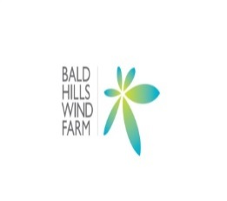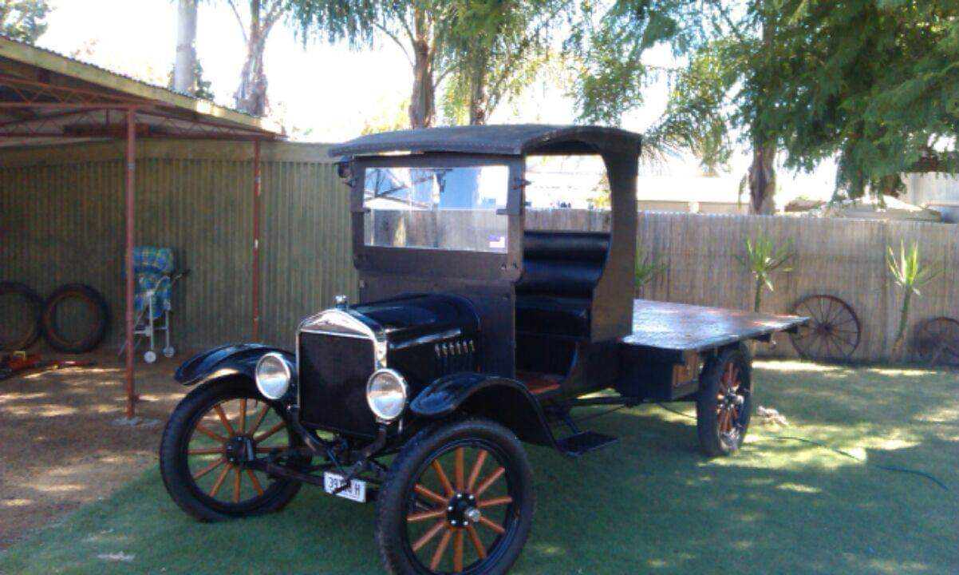

‘T’ MODEL FORD coming to TARWIN from DENILIQUIN.

